INTER DEPARTMENT PROJECT REPORT ON
“Health Monitoring System using ESP-2866 and Arduino”

Submitted

By
S.Sai chandana  191FA04351 | M.Chandralekha  191FA04388
Ch.Jahnavi  191FA04369 | N.Divya  191FA04398
G.Hemavalli  191FA04378 | Vishal  191FA05065
- Dinesh
191FA05038

Under the guidance of
Mr.KV.Ranga Rao, Asst Prof
Mr. Azeem Abdul, Asst Prof



DEPARTMENT OF COMPUTER SCIENCE & ENGINEERING
VIGNAN'S FOUNDATION FOR SCIENCE, TECHNOLOGY AND RESEARCH Deemed to be UNIVERSITY
Vadlamudi, Guntur.

VIGNAN’S FOUNDATION FOR SCIENCE TECHNOLOGY AND RESEARCH
Deemed to be UNIVERSITY
VADLAMUDI, GUNTUR DIST, ANDHRA PRADESH, INDIA, PIN-522 213

CERTIFICATE

This is to certify that the Inter Department Project Report entitled ““Health Monitoring System using ESP-2866 and Arduino”” that is being submitted by Jahnavi(191fa04369) in association with Chandraleka(191FA04388), Hemavalli(191FA04378), Divya(191FA04398), in partial fulfilment of Inter Department Project course work is a bonafide work carried under the supervision of Azeem Abdhul, Designation from Department of Computer Science & Engineering.

Mr.KV.Ranga Rao Azeem Abdul Dr.VenkatesuluDondeti Asst Prof Asst Prof HOD, CSE

For the External Inter Department Project Vive-voce scheduled on 2-2-22
Internal Examiner External Examiner

VIGNAN’S FOUNDATION FOR SCIENCE TECHNOLOGY AND RESEARCH
Deemed to be UNIVERSITY
VADLAMUDI, GUNTUR DIST, ANDHRA PRADESH, INDIA, PIN-522 213

DECLARATION
We hereby declare that the Inter Department Project entitled “Health Monitoring System using ESP-2866 and Arduino” is being submitted by S.Sai Chandana(191FA04351), Ch.Jahanavi(191FA04369), N.Divya(191fa04398), G.HemaValli(191FA04378), M.Chandralekha(191Fa04388) in partial fulfilment of Inter Department Project course work.
This dissertation is our original work, and the project has not formed the basis for the award of any degree. We have worked in association with Dinesh (191FA05038), Vishal(191FA05065) under the supervision of Azeem Abdhul, Designation from Department of Computer Science & Engineering

By
- Sai Chandana
Ch.Jahanavi
- Hemavalli
M.ChandraLeka
N.Divya
Vishal
M.Dinesh

Date: 2-02-2022

Problem statement:

Biometrics devices can take unique information about you from your eye, or your hand prints, or your thumb prints and use it to identify you. This information can be used to obtain the valuable healthcare information. The personal health monitoring of each individual is considered very important because of rise in health problems in today's world. The increasing stressful lifestyle is taking maximum toll on the public health. With the ever increasing queues at hospitals and ever increasing number of patients, the doctor fees have sky-rocketed which is affecting especially those patients who cannot afford the fee or who are not suffering from major ailments but get to know so only after paying a hefty fee to the doctor.
The researchers and surveys often demonstrate that most of the major health ailments are the result of careless attitude towards the minor health ailments. Majority of these issues can be solved by just following a good diet, proper sleep pattern and regular exercising. But how does a patient know what diet is good or what exercise he/she should follow and more importantly whether the plan that he is following is working effectively for him. The absence of such a mechanism makes the task of patient a difficulty, thus landing him with an option either to go to the doctor that means heavy fee or ignore the ailment that is more dangerous.

Abstract:
The healthcare monitoring systems has emerged as one of the most vital system and became technology oriented from the past decade. Humans are facing a problem of unexpected death due to various illness which is because of lack of medical care to the patients at right time. The primary goal was to develop a reliable patient monitoring system using IoT so that the healthcare professionals can monitor their patients, who are either hospitalized or at home using an IoT based integrated healthcare system with the view of ensuring patients are cared for better. A mobile device based wireless healthcare monitoring system was developed which can provide real time online information about physiological conditions of a patient mainly consists of sensors, the data acquisition unit, micro controller (i.e., Arduino), and programmed with a software. The patient’s temperature, heart beat rate, EEG data are monitored, displayed and stored by the system and sent to the doctor’s mobile containing the application. Thus, IoT based patient monitoring system effectively monitor patient’s health status and save life on time.

The System will basically consists of three different users that would be interacting with the aim of providing better healthcare service through mutual utilization of self-monitoring and the consultation from a specialist. The mutual interaction exists because user will have the option of sending the data for analysis to the doctor, getting the feedback and then acting on his advice. The three users are:-

1. Patient
2. Doctor
3. Administrator

Introduction:

Health monitoring systems provide valuable insight into the condition of a structure, enabling planners to make better decisions regarding maintenance, and help to ensure the safety of a structure’s inhabitants. Unfortunately, two factors have led to the lack of widespread adoption of structural health monitoring systems. First, systems are expensive to install with costs increasing faster than a linear rate as systems grow in size. Second, the benefits currently derived from a permanently installed structural monitoring system are difficult to quantify in terms of costs saved to structural owners. Clearly, if the installation cost of monitoring systems can be reduced, while system capabilities are expanded to include robust identification of structural damage, implementation of health monitoring systems would become more widespread.

Requirements specification:

- Arduino IDE
- OLED display
- MLX90614 Temperature sensor.
- AD8232 Pulse sensor
- MAX30102 Oximeter
- Battery
- USB cable
- Connecting wires

BLOCK DIAGRAM:

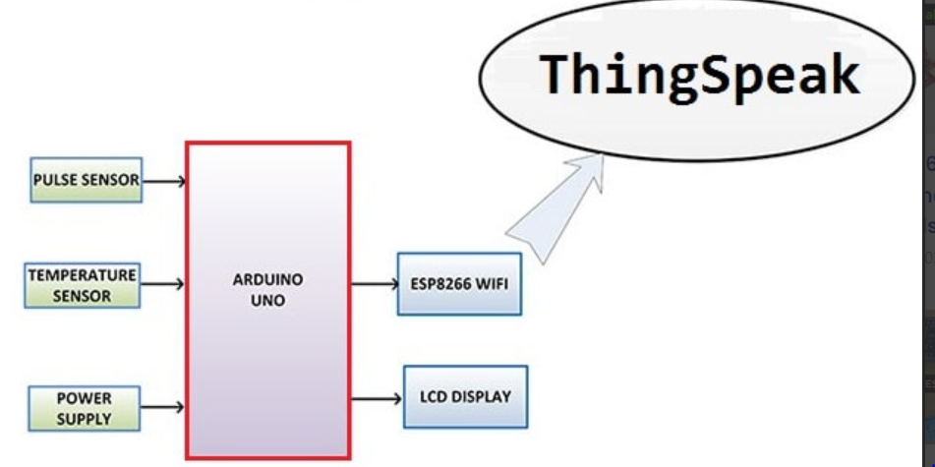

This is a simple block diagram that explains the IoT Based Patient Health Monitoring System using ESP8266 & Arduino. Pulse Sensor and LM35 Temperature Sensors measure BPM & Environmental Temperature respectively. The Arduino processes the code and displays it to 16*2 LCD Display. ESP8266 Wi-Fi module connects to Wi-Fi and sends the data to IoT device server. The IoT server used here is Thingspeak.

1.Arduino UNO:

It is a microcontroller based on the
ATmega328P. It has 14 digital I/O pins (of which 6 can be used
as PWM outputs), 6 analog inputs, a 16 MHz quartz crystal, a
USB connection, a power jack, an ICSP header and a reset
Button.

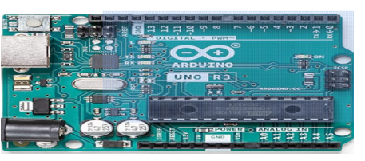
2.OLED display
The Organic Light-Emitting Diode, or simply OLED, is the technology used for the screen in the Arduino Sensor Kit. The OLED uses an organic, carbon based material for emitting light. ... The Grove OLED display 0.96" module's behavior can be controlled by using the Arduino_Sensor Kit library.

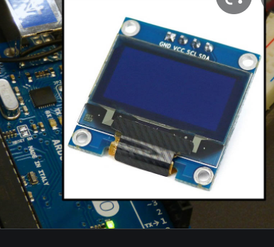

- Temperature Sensor:

It is an analog signal and micro controllers usually don't accept analog signals as their input directly. We need to convert this analog output signal to digital before we can supply it to a micro controller’s input.

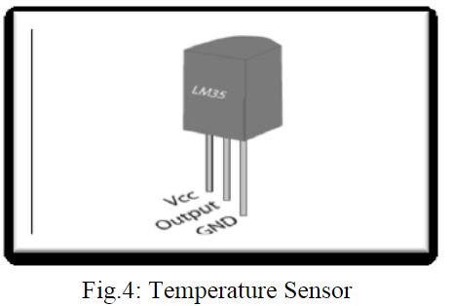

4.Heart beat sensor:

It is designed to give digital output of heat
beat when a finger is placed on it. When the heart beat detector
is working, the beat LED flashes in unison with each heartbeat.

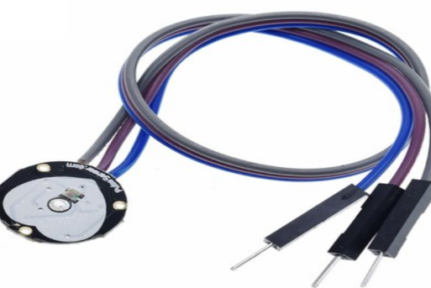

5..Oximeter:
The MAX30102 is an integrated pulse oximetry and heart-rate monitor biosensor module. It includes internal LEDs, photodetectors, optical elements, and low-noise electronics with ambient light rejection. The MAX30102 provides a complete system solution to ease the design-in process for mobile and wearable devices.

6.USB wire:
USB, in full universal serial bus, technology used to connect computers with peripheral devices. ... A USB port represented a standardized way to connect a wide range of devices while offering significant advantages in speed over other connection types.

Circuit diagram:

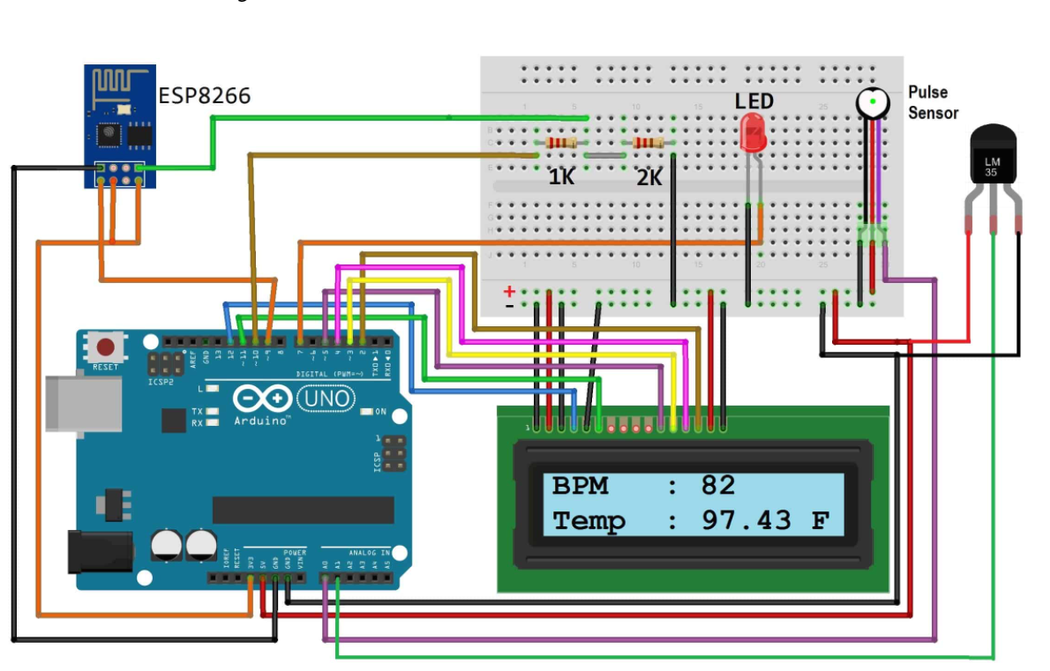

Circuit diagram Explanation:
- Connect Pulse Sensor output pin to A0 of Arduino and other two pins to VCC & GND.
- Connect LM35 Temperature Sensor output pin to A1 of Arduino and other two pins to VCC & GND.
- Connect the LED to Digital Pin 7 of Arduino via a 220-ohm resistor.
- Connect Pin 1,3,5,16 of LCD to GND.
- Connect Pin 2,15 of LCD to VCC.
- Connect Pin 4,6,11,12,13,14 of LCD to Digital Pin12,11,5,4,3,2 of Arduino.
- The RX pin of ESP8266 works on 3.3V and it will not communicate with the Arduino when we will connect it directly to the Arduino. So, we will have to make a voltage divider for it which will convert the 5V into 3.3V. This can be done by connecting the 2.2K & 1K resistor. Thus the RX pin of the ESP8266 is connected to pin 10 of Arduino through the resistors.
- Connect the TX pin of the ESP8266 to pin 9 of the Arduino.

Advantage of this project
1) IOT Monitoring proves really helpful when we need to monitor & record and keep track of changes in the health parameters of the patient over a period of time. So with the IOT health monitoring, we can have the database of these changes in the health parameters. Doctors can take the reference of these changes or the history of the patient while suggesting the treatment or the medicines to the patient.
2) Hospital stays are minimized due to Remote Patient Monitoring.
3) Hospital visits for normal routine checkups are Minimized

Future development:
We can add a GPS module in IOT patient monitoring using the Arduino Uno and the WiFi module project. This GPS module will find out the position or the location of the patient using the longitude and latitude received. Then it will send this location to the cloud that is the IOT using the Wi-Fi module. Then doctors can find out the position of the patient in case they have to take some preventive action.

Advantages:
- Increased patient comfort and convenience enable better patient satisfaction and faster recovery times.
- IoT healthcare devices, wearable technology and data access allow physicians to monitor patients with greater precision and provide better-informed treatment.

Disadvantages:
- Privacy of Data. Privacy is the biggest challenge with IoT, as all the connected devices transfer data in real-time. Personal data can be hacked if this end to end connection is not secure. ...
- Accuracy. Accuracy issues may come due to handling such massive data in real-time.
- Cost.

TECHNOLOGIES ADOPTED:

Thing speak:
ThingSpeak™ is an IoT analytics platform service that allows you to aggregate, visualize and analyze live data streams in the cloud. ThingSpeak provides instant visualizations of data posted by your devices to ThingSpeak. With the ability to execute MATLAB® code in ThingSpeak you can perform online analysis and processing of the data as it comes in. ThingSpeak is often used for prototyping and proof of concept IoT systems that require analytics.
- ThingSpeak is Iot Cloud platform where you can send sensor data to the cloud. You can also analyze and visualize your data with MATLAB or other software, including making your own applications.
- The ThingSpeak service is operated by MathWorks. In order to sign up for ThingSpeak, you must create a new MathWorks Account or log in to your existing MathWorks Account.
- ThingSpeak is free for small non-commercial projects.
- ThingSpeak includes a Web Service (REST API) that lets you collect and store sensor data in the cloud and develop Internet of Things applications. It works with Arduino, Raspberry Pi and MATLAB (premade libraries and APIs exists) But it should work with all kind of Programming Languages, since it uses a REST API and HTTP

DESIGN AND IMPLEMENTATION OF SOLUTION

IMPLEMENTATION :
Once the hardware is set up, we can go ahead and create our Thing Speak Channel.
Step 1: Go to https://thingspeak.com/ and create your Thing Speak Account if you don’t have. Login to Your Account.
Step 2: Create a Channel by clicking ‘New Channel’. After clicking on the above link, you will get the page as shown below.
Step 3: Enter the channel details.
Field 1: Temperature – This will be displayed on the analytics graph.
Field 2: Humidity
Field 3: Gas Save this setting. Give the name and select the fields and allot respective names to the fields
Step 4: Now you can see the channels. Click on the ‘API Keys’ tab. Here you will get the Channel ID and API Keys
Step 5: Open Arduino IDE and Install the Thing Speak Library. To do this go to Sketch>Include Library>Manage Libraries. Search for Thing Speak and install the library
Step 6: Now we need to modify the program with your credentials. In the below code you need to change your Network SSID, Password and your ThingSpeak Channel and API Keys.
Replace the following content in the code,

‘Your SSID Here’ – Your Wi-Fi Name.
‘Your Password Here’ – Your Wi-Fi Password ‘YYYYYY’
Your ThingSpeak Channel Number (without Quotes) ‘XXXXXXXXXXX’
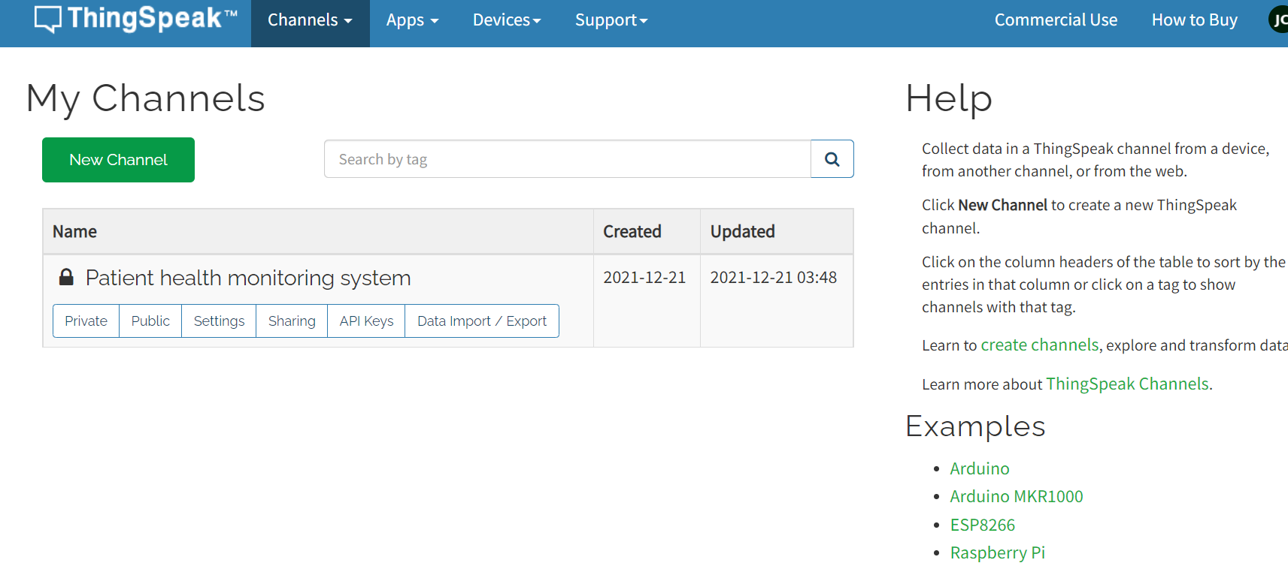

Source Code:
#include <LiquidCrystal.h>
LiquidCrystal lcd(12, 11, 5, 4, 3, 2);
#include <SoftwareSerial.h>
float pulse = 0;
float temp = 0;
SoftwareSerial ser(9,10);
String apiKey = "OO707TGA1BLUNN12";
// Variables
int pulsePin = A0; // Pulse Sensor purple wire connected to analog pin 0
int blinkPin = 7 ; // pin to blink led at each beat
int fadePin = 13; // pin to do fancy classy fading blink at each beat
int fadeRate = 0; // used to fade LED on with PWM on fadePin
// Volatile Variables, used in the interrupt service routine!
volatile int BPM; // int that holds raw Analog in 0. updated every 2mS
volatile int Signal; // holds the incoming raw data
volatile int IBI = 600; // int that holds the time interval between beats! Must be seeded!
volatile boolean Pulse = false; // "True" when User's live heartbeat is detected. "False" when nota "live beat".
volatile boolean QS = false; // becomes true when Arduoino finds a beat.
// Regards Serial OutPut -- Set This Up to your needs
static boolean serialVisual = true; // Set to 'false' by Default. Re-set to 'true' to see Arduino Serial Monitor ASCII Visual Pulse
volatile int rate[10]; // array to hold last ten IBI values
volatile unsigned long sampleCounter = 0; // used to determine pulse timing
volatile unsigned long lastBeatTime = 0; // used to find IBI
volatile int P = 512; // used to find peak in pulse wave, seeded
volatile int T = 512; // used to find trough in pulse wave, seeded
volatile int thresh = 525; // used to find instant moment of heart beat, seeded
volatile int amp = 100; // used to hold amplitude of pulse waveform, seeded
volatile boolean firstBeat = true; // used to seed rate array so we startup with reasonable BPM
volatile boolean secondBeat = false; // used to seed rate array so we startup with reasonable BPM
void setup(){
lcd.begin(16, 2);
pinMode(blinkPin,OUTPUT); // pin that will blink to your heartbeat!
pinMode(fadePin,OUTPUT); // pin that will fade to your heartbeat!
Serial.begin(115200); // we agree to talk fast!
interruptSetup(); // sets up to read Pulse Sensor signal every 2mS
// IF YOU ARE POWERING The Pulse Sensor AT VOLTAGE LESS THAN THE BOARD VOLTAGE,

// UN-COMMENT THE NEXT LINE AND APPLY THAT VOLTAGE TO THE A-REF PIN
// analogReference(EXTERNAL);
lcd.clear();
lcd.setCursor(0,0);
lcd.print(" Patient Health");
lcd.setCursor(0,1);
lcd.print(" Monitoring ");
delay(4000);
lcd.clear();
lcd.setCursor(0,0);
lcd.print("Initializing....");
delay(5000);
lcd.clear();
lcd.setCursor(0,0);
lcd.print("Getting Data....");
ser.begin(9600);
ser.println("AT");
delay(1000);
ser.println("AT+GMR");
delay(1000);
ser.println("AT+CWMODE=3");
delay(1000);
ser.println("AT+RST");
delay(5000);
ser.println("AT+CIPMUX=1");
delay(1000);

String cmd="AT+CWJAP=\"Alexahome\",\"98765432\"";
ser.println(cmd);
delay(1000);
ser.println("AT+CIFSR");
delay(1000);
}
// Where the Magic Happens
void loop()
{
serialOutput();
if (QS == true) // A Heartbeat Was Found
{
// BPM and IBI have been Determined
// Quantified Self "QS" true when arduino finds a heartbeat
fadeRate = 255; // Makes the LED Fade Effect Happen, Set 'fadeRate' Variable to 255 to fade LED with pulse
serialOutputWhenBeatHappens(); // A Beat Happened, Output that to serial.
QS = false; // reset the Quantified Self flag for next time
}
ledFadeToBeat(); // Makes the LED Fade Effect Happen
delay(20); // take a break
read_temp();
esp_8266();
}
void ledFadeToBeat()
{
fadeRate -= 15; // set LED fade value
fadeRate = constrain(fadeRate,0,255); // keep LED fade value from going into negative numbers!
analogWrite(fadePin,fadeRate); // fade LED
}
void interruptSetup()
{
// Initializes Timer2 to throw an interrupt every 2mS.
TCCR2A = 0x02; // DISABLE PWM ON DIGITAL PINS 3 AND 11, AND GO INTO CTC MODE
TCCR2B = 0x06; // DON'T FORCE COMPARE, 256 PRESCALER
OCR2A = 0X7C; // SET THE TOP OF THE COUNT TO 124 FOR 500Hz SAMPLE RATE
TIMSK2 = 0x02; // ENABLE INTERRUPT ON MATCH BETWEEN TIMER2 AND OCR2A
sei(); // MAKE SURE GLOBAL INTERRUPTS ARE ENABLED
}
void serialOutput()
{ // Decide How To Output Serial.
if (serialVisual == true)
{
arduinoSerialMonitorVisual('-', Signal); // goes to function that makes Serial Monitor Visualizer
}
else
{
sendDataToSerial('S', Signal); // goes to sendDataToSerial function
}
}
void serialOutputWhenBeatHappens()
{
if (serialVisual == true) // Code to Make the Serial Monitor Visualizer Work
{
Serial.print("*** Heart-Beat Happened *** "); //ASCII Art Madness
Serial.print("BPM: ");
Serial.println(BPM);
}
else
{
sendDataToSerial('B',BPM); // send heart rate with a 'B' prefix
sendDataToSerial('Q',IBI); // send time between beats with a 'Q' prefix
}
}
void arduinoSerialMonitorVisual(char symbol, int data )
{
const int sensorMin = 0; // sensor minimum, discovered through experiment
const int sensorMax = 1024; // sensor maximum, discovered through experiment
int sensorReading = data; // map the sensor range to a range of 12 options:
int range = map(sensorReading, sensorMin, sensorMax, 0, 11);
// do something different depending on the
// range value:
switch (range)
{
case 0:
Serial.println(""); /////ASCII Art Madness
break;
case 1:
Serial.println("---");
break;
case 2:
Serial.println("------");
break;
case 3:
Serial.println("---------");
break;
case 4:
Serial.println("------------");
break;
case 5:
Serial.println("--------------|-");
break;
case 6:
Serial.println("--------------|---");
break;
case 7:
Serial.println("--------------|-------");
break;
case 8:
Serial.println("--------------|----------");
break;
case 9:
Serial.println("--------------|----------------");
break;
case 10:
Serial.println("--------------|-------------------");
break;
case 11:
Serial.println("--------------|-----------------------");
break;
}
}
ndvoid sendDataToSerial(char symbol, int data )
{
Serial.print(symbol);
Serial.println(data);
}
ISR(TIMER2_COMPA_vect) //triggered when Timer2 counts to 124
{
cli(); // disable interrupts while we do this
Signal = analogRead(pulsePin); // read the Pulse Sensor
sampleCounter += 2; // keep track of the time in mS with this variable
int N = sampleCounter - lastBeatTime; // monitor the time since the last beat to avoid noise
// find the peak a trough of the pulse wave

if(Signal < thresh && N > (IBI/5)*3) // avoid dichrotic noise by waiting 3/5 of last IBI
{
if (Signal < T) // T is the trough
{
T = Signal; // keep track of lowest point in pulse wave
}
}
if(Signal > thresh && Signal > P)
{ // thresh condition helps avoid noise
P = Signal; // P is the peak
} // keep track of highest point in pulse wave
// NOW IT'S TIME TO LOOK FOR THE HEART BEAT
// signal surges up in value every time there is a pulse
if (N > 250)
{ // avoid high frequency noise
if ( (Signal > thresh) && (Pulse == false) && (N > (IBI/5)*3) )
{
Pulse = true; // set the Pulse flag when we think there is a pulse
digitalWrite(blinkPin,HIGH); // turn on pin 13 LED
IBI = sampleCounter - lastBeatTime; // measure time between beats in mS
lastBeatTime = sampleCounter; // keep track of time for next pulse

if(secondBeat)
{ // if this is the second beat, if secondBeat == TRUE
secondBeat = false; // clear secondBeat flag
for(int i=0; i<=9; i++) // seed the running total to get a realisitic BPM at startup
{
rate[i] = IBI;
}
}
if(firstBeat) // if it's the first time we found a beat, if firstBeat == TRUE
{
firstBeat = false; // clear firstBeat flag
secondBeat = true; // set the second beat flag
sei(); // enable interrupts again
return; // IBI value is unreliable so discard it
}
// keep a running total of the last 10 IBI values
word runningTotal = 0; // clear the runningTotal variable
for(int i=0; i<=8; i++)
{ // shift data in the rate array
rate[i] = rate[i+1]; // and drop the oldest IBI value
runningTotal += rate[i]; // add up the 9 oldest IBI values
}
rate[9] = IBI; // add the latest IBI to the rate array
runningTotal += rate[9]; // add the latest IBI to runningTotal
runningTotal /= 10; // average the last 10 IBI values
BPM = 60000/runningTotal; // how many beats can fit into a minute? that's BPM!
QS = true; // set Quantified Self flag
// QS FLAG IS NOT CLEARED INSIDE THIS ISR
pulse = BPM;
}
}
if (Signal < thresh && Pulse == true)
{ // when the values are going down, the beat is over
digitalWrite(blinkPin,LOW); // turn off pin 13 LED
Pulse = false; // reset the Pulse flag so we can do it again
amp = P - T; // get amplitude of the pulse wave
thresh = amp/2 + T; // set thresh at 50% of the amplitude
P = thresh; // reset these for next time
T = thresh;
}
if (N > 2500)
{ // if 2.5 seconds go by without a beat
thresh = 512; // set thresh default
P = 512; // set P default
T = 512; // set T default
lastBeatTime = sampleCounter; // bring the lastBeatTime up to date
firstBeat = true; // set these to avoid noise
secondBeat = false; // when we get the heartbeat back
}
sei(); // enable interrupts when youre done!
}// end isr
void esp_8266()
{
// TCP connection AT+CIPSTART=4,"TCP","184.106.153.149",80
String cmd = "AT+CIPSTART=4,\"TCP\",\"";
cmd += "184.106.153.149"; // api.thingspeak.com
cmd += "\",80";
ser.println(cmd);
Serial.println(cmd);
if(ser.find("Error"))
{
Serial.println("AT+CIPSTART error");
return;
}
String getStr = "GET /update?api_key=";
getStr += apiKey;
getStr +="&field1=";
getStr +=String(temp);
getStr +="&field2=";
getStr +=String(pulse);
getStr += "\r\n\r\n";
// send data length
cmd = "AT+CIPSEND=4,";
cmd += String(getStr.length());
ser.println(cmd);
Serial.println(cmd);
delay(1000);
ser.print(getStr);
Serial.println(getStr); //thingspeak needs 15 sec delay between updates
delay(3000);
}
void read_temp()
{
int temp_val = analogRead(A1);
float mv = (temp_val/1024.0)*5000;
float cel = mv/10;
temp = (cel*9)/5 + 32;
Serial.print("Temperature:");
Serial.println(temp);
lcd.clear();
lcd.setCursor(0,0);
lcd.print("BPM :");
lcd.setCursor(7,0);
lcd.print(BPM);
lcd.setCursor(0,1);
lcd.print("Temp.:");
lcd.setCursor(7,1);
lcd.print(temp);
lcd.setCursor(13,1);
lcd.print("F");
}

Sample outputs

DESIGN OF TESTCASES & TESTING

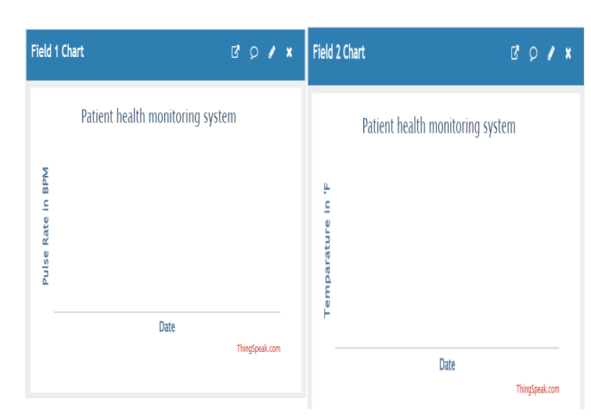

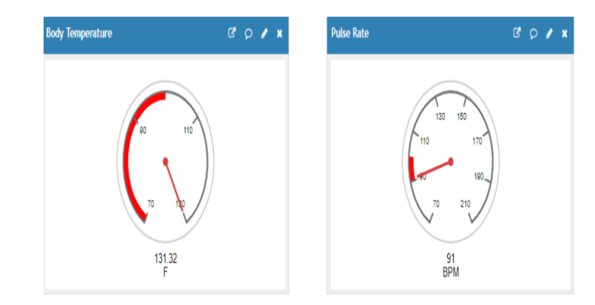

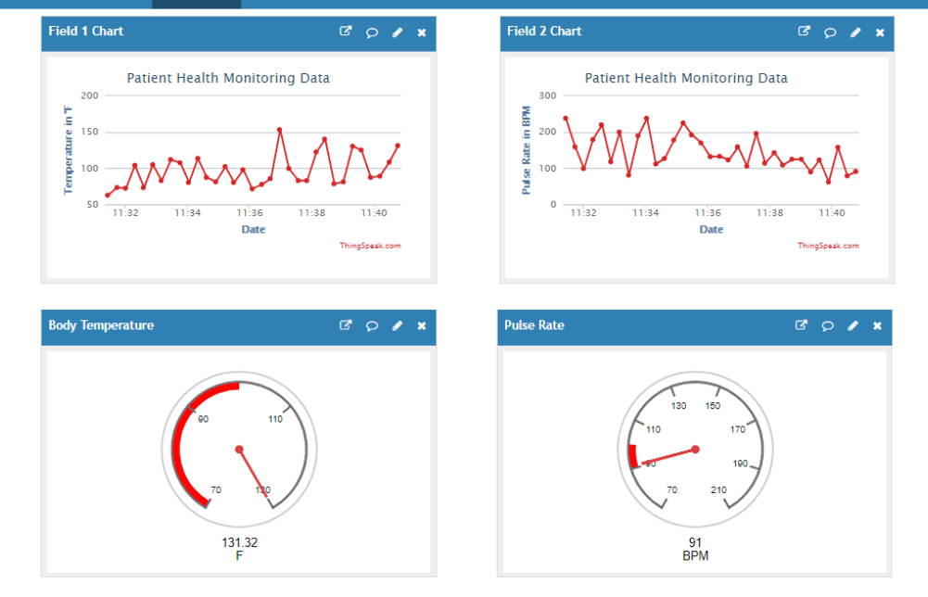

Conclusion:

With the wide use of internet, this work is concentrated to execute the internet technology to establish a system which would communicate through internet for better health. Internet of Things rules the whole world in various fields, mainly in health care sectors. Hence the present work is done to design an Internet of Things based smart patient health tracking system using an Arduino microcontroller. In this, pulse rate sensor is used to detect the heart beat and temperature sensor to read the temperature and sends the data to the cloud using internet. This information is also sent to the LCD display, so patient can easily know their health status. During critical situations to alert the doctor, the warning message is sent to the doctor’s phone and at the same time buzzer turns to alert the care taker. The doctor can view the sent data by logging the specific website or IP address.

BIBLIOGRAPHY
₋1. Gibson HM. Managing your wireless spectrum... Making wireless technology work in your hospital. Biomed Instrum Technol. 2006 Suppl:30–36. [PubMed]
- Getting the message: results of our survey on cell phone/smartphone policies. Health Devices. 2013;42(4):126–132. [PubMed]
- Kapa S, Pierce T, Hayes DL, Holmes DR Jr, Asirvatham SJ. Electromagnetic interference of magnetic field based auto identification technologies in healthcare settings. Int J Med Inform. 2011 Apr;80(4):239–250. [PubMed]
- Judgment call. Health Devices. 2012;4110:314–329. [PubMed]
- Methodology checklist 1: systematic reviews and meta-analyses [Internet]. Edinburgh: Scottish Intercollegiate Guidelines Network (SIGN). 2004 Mar [cited 2014 Jan 17]; Available from: http://www​.sign.ac.uk/pdf/sign50annexc​.pdf.
- Scottish Intercollegiate Guidelines Network. Methodology checklist 3: cohort studies [Internet]. In: SIGN 50: a guideline developer's handbook. Edinburgh: SIGN. 2013 [cited 2014 Jan 17]; Available from: http://www​.sign.ac.uk​/guidelines/fulltext/50/checklist3.html.
- Carranza N, Febles V, Hernandez JA, Bardasano JL, Monteagudo JL, Fernandez de Aldecoa JC, et al. Patient safety and electromagnetic protection: a review. Health Phys. 2011 May;100(5):530–541. [PubMed]
- Calcagnini G, Mattei E, Censi F, Triventi M, Lo SR, Marchetta E, et al. Electromagnetic compatibility of WLAN adapters with life-supporting medical devices. Health Phys. 2011 May;100(5):497–501. [PubMed]

